3D Game Development

Using a popular game engine to create and develop a fully functional and robust game with specific features which provide player a sense of enjoyability.

Student: Nathan Hor Yew Jun Candidate Number: 263152 Supervisor: Dr. Natalia Beloff

Aims

The aim of the project is to develop a horror adventure 3D game based off a well known Korean comic. This game will be made using the Unity game engine. The main reason this game is 3D is because players now want to immerse themselves into a realistic game environment with immersive storytelling with as much authenticity as possible (1).

The purpose of this project is to experiment on what makes a scary game immersive for a player to have a sense of fear towards it. Horror games has been one of the few dominant genre of the gaming industry for the past decade. Some of the game mechanics in this game will be inspired from the likes of Outlast and Alien: Isolation. The game will consist of basic player character movements, including dodging and dashing.

With this project, one of the objective is to have an attempt at replicating the horror atmosphere that has been established from the original source[2]. The unique enemies established in the story with the immersive narrative which is fully fleshed out by the author himself is nothing to be taken lightly of. This game will be education on teaching me how to incorporate textures, lighting and many other techniques to enhance the horror gameplay for the players. The game will be developed as such that it will have a level of complexity with real time collision detection and save points.

Objective

Primary Objective

1. Researching other Horror 3d games that will guide me in designing my prototype
2. Identifying why it has peaked my interest and why I am inspired by them
3. Conducting user research to determine the target audience for my project
4. Design the prototype of the game while taking into account of the research and interview done
5. Conduct user testing by introducing playtesting for the game and receiving valuable feedback
6. Improve on the prototype and repeat playtesting process

Relevance

This project will aid me in using the Unity game Engine more effectively. My C# programming skills will also improve through the development of this project. My 3D animation and modelling skills will improve through creating the character model for the game also the models for the enemies for this game. I will also gain insight into level design by designing levels for my game which will include boss levels and levels with puzzles.

I have been interested in the development of this project since I was 18 years old. But due to my lack of programming knowledge and general lack of knowledge with Unity, I have refrained from starting this project. I have admired the amazing storyline the game has to offer, and I intend to craft this game purely out of my admiration for the author and respect for the effort he has put into crafting the story.

Resource required

The resource that is required for this project is a desktop with sufficient graphical and processing power. A student plan on my Unity game engine is needed to have access to the free assets in the Unity asset store. Some software program are needed as well such as the modelling program Blender. All these software will aid me in completing this project.

Weekly timetable

|  |  |  |  |  |  |  |
| --- | --- | --- | --- | --- | --- | --- |
| Monday | Tuesday | Wednesday | Thursday | Friday | Saturday | Sunday |
| Human  Comp. Interaction  *11-1pm*  *3-4pm* | Visual Effects  *10-11pm* | Project/Coursework  6 hours | 3D Programming  *11-1pm* | Visual Effect  *9-11am* | Part time work  *12-7pm* | Project/Coursework  6 hours |
| Project/  Coursework  3 hours | 3D Programming  *11-1pm* |  | Project/  Coursework  3 hours | Part time work  *5-8pm* |  |  |
|  | Individual Project  *2-3pm* |  |  | Project/Coursework  2 hours |  |  |
|  | Project/Coursework  3 hours |  |  |  |  |  |

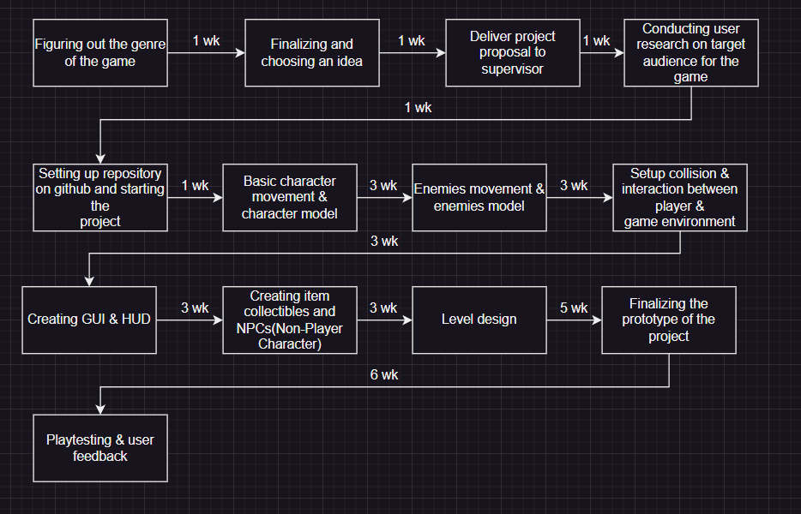Project timescale

Bibliography

1. Starloop, S.(2023). Starloop Studios. [online] starloopstudios.com. Available at: <https://starloopstudios.com/3d-vs-2d-the-eternal-battle-to-develop-video-games/#:~:text=3D%20games%20have%20become%20increasingly,they%20encounter%20in%203D%20games>.
2. Kim, C.(2018). Sweet home. [online] webtoons.com.Available at: <https://www.webtoons.com/en/thriller/sweethome/list?title_no=1285>